**MANAGING BIG EMOTIONS THROUGH MOVEMENT: YOGA FOR KIDS**

Simple yoga sequence for kids to use as calm down activities for your child.

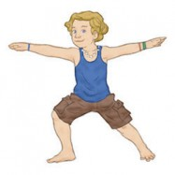**“I am strong.”** Pretend to be a surfer.  
**To do Warrior 2 Pose:** From standing position, step one foot back, placing the foot so that it is facing slightly outwards. Take your arms up in parallel to the ground, bend your front knee, and look forward. Pretend to be a surfer and use your strength to catch tricky waves.

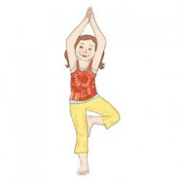**“I am kind.”** Pretend to be a tree.  
**To do Tree Pose:** Stand on one leg, bend your knee, place the sole of your foot on the opposite inner thigh, and balance. Sway like a tree. Think of trees being kind by offering shade, creating oxygen, and providing homes to animals.

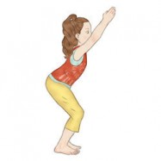**“I am brave.”** Pretend to be a skier.  
**To do Chair Pose:** Stand tall with your feet hip-width apart, bend your knees, and keep a straight spine. Hold your hands out in front of you, pretending to grasp ski poles as you fly down a ski run like a brave and fearless skier.

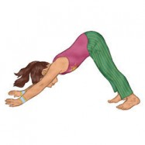**“I am friendly.”** Pretend to be a dog.  
**To do Downward-Facing Dog Pose:** Bend down and place your palms flat on the ground. Step your feet back to create an upside-down V shape with your buttocks high in the air. Straighten your legs, relax your head and neck, and look down between your legs. Think of being an eager and friendly dog.

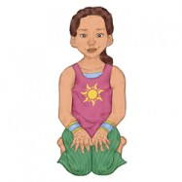**“I am wise.”** Pretend to be an owl.  
**To do Hero Pose:** Drop your knees to the ground and come down to rest upright on your heels. Then pretend to be a wise owl perched on a tree. Twist your upper body one way and then the other.